# INTRODUCTION TO PROJECT

The web based “CRICKET EQUIPMENT SHOPPING” project is an attempt to stimulate the basic concepts of shopping of Cricket Equipment Online. The system enables the customer to do the things such as search for different Cricket Equipment like Bat, Ball, Gloves, Shoes, Clothing of many Brands and purchasing the equipment .

The system also provides you to view Cricket Score of all Cricket Matches

either which had been played earlier or are currently playing.

The system provides you Quick Search facility that provides you details about cricket player. It must require login into your account.

The website has facility to search for a Cricket equipment that are available in many Brands and price. Some brands as 'Adidas English willow Bat', 'Spartan Kashmir Willow Bat', 'Kookaburra Batting Gloves', 'SS Wicket Keeping Gloves' etc. The website displays all the Equipment details category-wise like BAT, BALL, SHOES, GLOVES, CLOTHING.

Here we provided quick search facility which displays list of available Brands for equipment and allows customer to choose a particular equipment. Then the system checks for the availability of equipment in the stock. If the equipment is available then the website allows the customer to add the equipment into the cart. Otherwise it asks the user to choose Equipment of another brand.

To book a order the website asks the customer to enter his details such as name, address, city, state and contact number. Then it checks the amount of order and book the order and update the product database and customer database.

**2.REQUIREMENTS**

**2.1 FUNCTIONAL REQUIREMENTS**

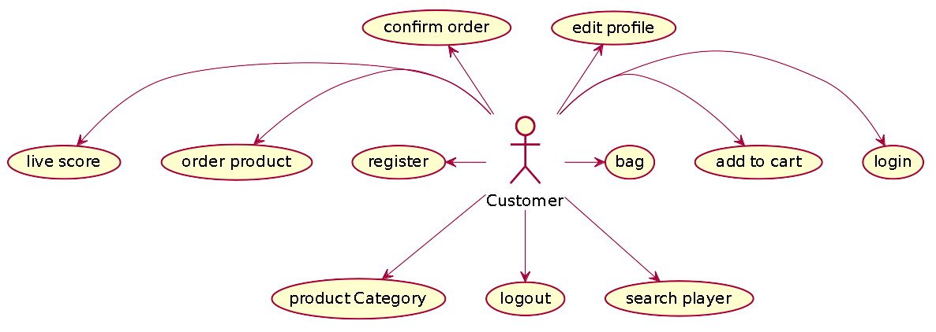

**2.1 User Account**

The customer, who will henceforth be called the ‘user’, will be presented with 3 choices by the cricket equipment shopping, as the first step in the interaction between them. A user can choose any product category-wise which he/she wants to buy.

The customer first has to be registered if he didn’t register earlier. He has to give all necessary details about him like name, address, state etc.

A user who has already registered earlier would have been given a user id and a password. This ‘personal information’ would be henceforth referred to as ‘profile’. Such a user with a profile in DB-user shall be called a ‘registered user’. A registered user will be able to check the availability of cricket equipment & can view the live cricket score by logging into the website.

A new user, on the other hand, would either have to

1. register himself with the system by providing personal information or

In case of ‘a’, the new user becomes a registered user.

Availability of Equipment always refers to the customer on the basis of brands, category, price & ratings.

With the option of ‘add to cart’ customer can add that particular product it his bag and by click on confirm order and pay he can successfully place his order.

**2.2 Registration and creation of user profile**

The system shall require a user to register, in order to carry out any transactions with it except for checking the availability of products. It will ask the user for the following information at the least – a user id, a password, first name, last name, address, phone number, email address.

* 1. **Quick Search**

Here we provided Quick Search facility for customer. If he wants to view see Cricket career of a Player then he has a feature to search player by name. By entering the player name, the all information about that player would be shown.

* 1. **Making Order Confirm**

After having taken the user through the step 2.2, Checking Availability, The system will now ask the user if he wishes to block/buy the product. If yes, and

1. If the user is already a registered user, he can block/buy the product, but if he has not a user, he will have to register.

After ensuring that user has login successfully, he would be able to buy that product.

**2.5 View Order History**

The system shall allow a user to view all information about his previous shopping. After logging him on, it asks for his blocking number or his confirmation number.

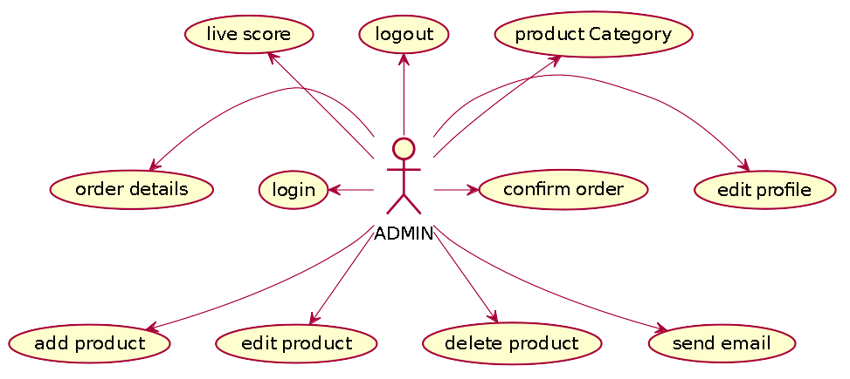

Admin should be able to login ,add product category-wise ,Delete product, see order Details and see user Information according to user Id.

**2.2.3 Constraint**

Cricmart shall be able to handle at least 1000 transactions/inquiries persecond

**2.2.4 Other Requirements:**

* **Hardware Interfaces**

The SPMS is expected to function on Intel PIII 900 MHz Processor equivalent or above, 128 MB RAM, 20 GB HDD.

* **Software Interfaces**

The SPMS shall work on MS Windows operating systems family (MS Windows 98, MS Windows NT Workstation, MS Windows 2000, MS Windows XP). It configures to work with Oracle database. This System works on Apache Tomcat server. It uses browser IE 5.0 & above. It uses IIS 5.0 server.

**3. DESIGN**

**3.1 Database Design**

The following table structures depict the database design.

# Table1: Users

|  |  |  |  |
| --- | --- | --- | --- |
| **Column Name** | **Data Type** | **Length** | **Allow Null (1=Yes;0=No)** |
| UserID | Number | 4 | 0 |
| City | Varchar | 20 | 1 |
| Phonenumber | Varchar | 20 | 0 |
| Country | Varchar | 20 | 1 |
| Email | Varchar | 30 | 0 |
| Firstname | Varchar | 20 | 0 |
| State | Varchar | 20 | 1 |
| Lastname | Varchar | 20 | 0 |
| Role | Varchar | 255 | 1 |
| Pincode | Varchar | 11 | 1 |
| Password | Number | 20 | 0 |

### Table2: product

|  |  |  |  |
| --- | --- | --- | --- |
| ProductID | Number | 5 | 0 |
| category | Varchar | 255 | 1 |
| product_date | Date | 8 | 1 |
| product_description | Varchar | 50 | 1 |
| product_image | Longblob | 1000 | 1 |
| product_name | Varchar | 50 | 1 |
| Stock | Number | 3 | 0 |
| Product_price | Float | 126 | 0 |
| Ratings | Double | 8 | 0 |
| product_weight | Float | 126 | 0 |

**Table3: Orders**

|  |  |  |  |
| --- | --- | --- | --- |
| Order_Id | Number | 5 | 0 |
| Amount | Float | 126 | 0 |
| user_id | Number | 11 | 0 |
| order_date | Date | 8 | 1 |

### Table4:order_details

|  |  |  |  |
| --- | --- | --- | --- |
| Order_details_ID | Number | 10 | 0 |
| Price | Float | 15 | 1 |
| quantity | Number | 4 | 0 |
| order_id | Nimber | 4 | 1 |
| product_ID | Number | 4 | 1 |

**E-R Diagram,Dataflow diagram and Class Diagram:**

Go to Appendix A

**4. CODING STANDARDS IMPLEMENTED**

### Naming and Capitalization

Below summarizes the naming recommendations for identifiers in Pascal casing is used mainly (i.e. capitalize first letter of each word) with camel casing (capitalize each word except for the first one) being used in certain circumstances.

|  |  |  |  |
| --- | --- | --- | --- |
| **Identifier** | **Case** | **Examples** | **Additional Notes** |
| Class | Pascal | Product, User, Category, Orders | Class names should be based on "objects" or "real things" and should generally be **nouns**. No ‘_’ signs allowed. Do not use type prefixes like ‘C’ for class. |
| Method | Camel | getProducts, updateUser | Methods should use **verbs** or verb phrases. |
| Parameter | Camel | productName, address | Use descriptive parameter names. Parameter names should be descriptive enough that the name of the parameter and its type can be used to determine its meaning in most scenarios. |
| Interface | Pascal with "I" prefix | ProductDao | Do not use the ‘_’ sign |
| Exception Class | Pascal with "Exception" suffix | WebException, |  |

### Comments

* Comment each type, each non-public type member, and each region declaration.
* Use end-line comments only on variable declaration lines. End-line comments are comments that follow code on a single line.
* Separate comments from comment delimiters (apostrophe) or // with one space.
* Begin the comment text with an uppercase letter.
* End the comment with a period.
* Explain the code; do not repeat it.

**5. TEST REPORT**

**Another group called Linux did the testing and the report of the testing is given hereunder.**

**GENERAL TESTING:**

|  |  |  |  |  |
| --- | --- | --- | --- | --- |
| **SR-NO** | **TEST CASE** | **EXPECTED RESULT** | **ACTUAL RESULT** | **ERROR MESSAGE** |
| 1 | Login Page | Redirected to Next page | OK | Please enter email and password . |
| 2 | Register Page | Register page will open | Ok | Nothing |
| 3 | Edit Profile | both users and admin will update their profile | Ok | Nothing |
| 4 | Live scores | Gives all current matches | Ok | Nothing |
| 5 | Check particular Match details | Give particular matches score details | Ok | Nothing |
| 6 | Search player | Display player with name entered | Ok | Nothing |
| 7 | Category Bat | Display Bats | Ok | Nothing |
| 8 | Category Ball | Display balls | Ok | Nothing |
| 9 | Category gloves | Display gloves | Ok | Nothing |
| 10 | Category shoes | Display shoes | Ok | Nothing |
| 11 | Category clothing | Display clothing | Ok | Nothing |
| 12 | Logout | It will logout from user profile. | Ok | Nothing |
|  | **STATIC TESTING** |  |  |  |
| **SR-NO** | **Deviation** | **Program** |  |  |
| 1 | Commenting not followed | All Web Application |  |  |

**6. PROJECT MANAGEMENT RELATED STATISTICS**

|  |  |  |  |
| --- | --- | --- | --- |
| **DATE** | **WORK PERFORMED** | ****SLC Phase**** | **Additional Notes** |
| JAN 12,2020 | Project Allotment and User Requirements Gathering | Feasibility Study | Our team met the client Mr. Nitinkudale (CEO, SIIT Pune) to know his requirements. |
| JAN 17,2020 | Initial SRS Document Validation  And Team Structure Decided | Requirement Analysis  (Elicitation) | The initial SRS was presented to the client to understand his requirements better |
| JAN 18,2020 | Designing the use-cases, Class Diagram, Collaboration Diagram, E-R Diagram and User Interfaces | Requirement Analysis &  Design Phase | Database Design completed |
| JAN 19,2020 | Business Logic Component design Started | Design Phase | ---------------------- |
| JAN 20,2020 | Coding Phase Started | Coding Phase | 70% of Class Library implemented. |
| JAN 21,2020 | Implementation of Web Application and Window Application Started | Coding Phase | Class Library Development going on. |
| JAN 22, 2020 | Off | Off | Off |
| JAN 23, 2020 | Implementation of Web Application and Window Application Continued | Coding Phase and Unit Testing | Class Library Modified as per the need. |
| JAN 24, 2020 | Implementation of Web Application and Window Application Continued | Coding Phase and Unit Testing | -- |
| JAN 25, 2020 | After Ensuring Proper Functioning the Required Validations were Implemented | Coding Phase and Unit Testing | Module Integration was done by the Project Manager |
| JAN 26, 2020 | The Project was Tested by the respective Team Leaders and the Project Manager | Testing Phase (Module Testing) | -- |
| JAN 27, 2020 | The Project was Submitted to Other Project Leader of Other Project Group For Testing | Testing Phase (Acceptance Testing) | The Project of Other Team was Taken up by the Team for Testing |
| JAN 28-29, 2020 | The Errors Found were Removed | Debugging | The Project was complete for submission |
| JAN 30, 2020 | Final Submission of Project |  |  |

**Class Diagram**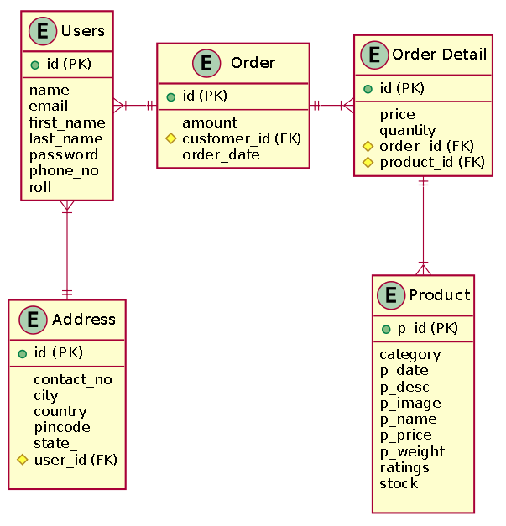

Appendix B

Loginpage: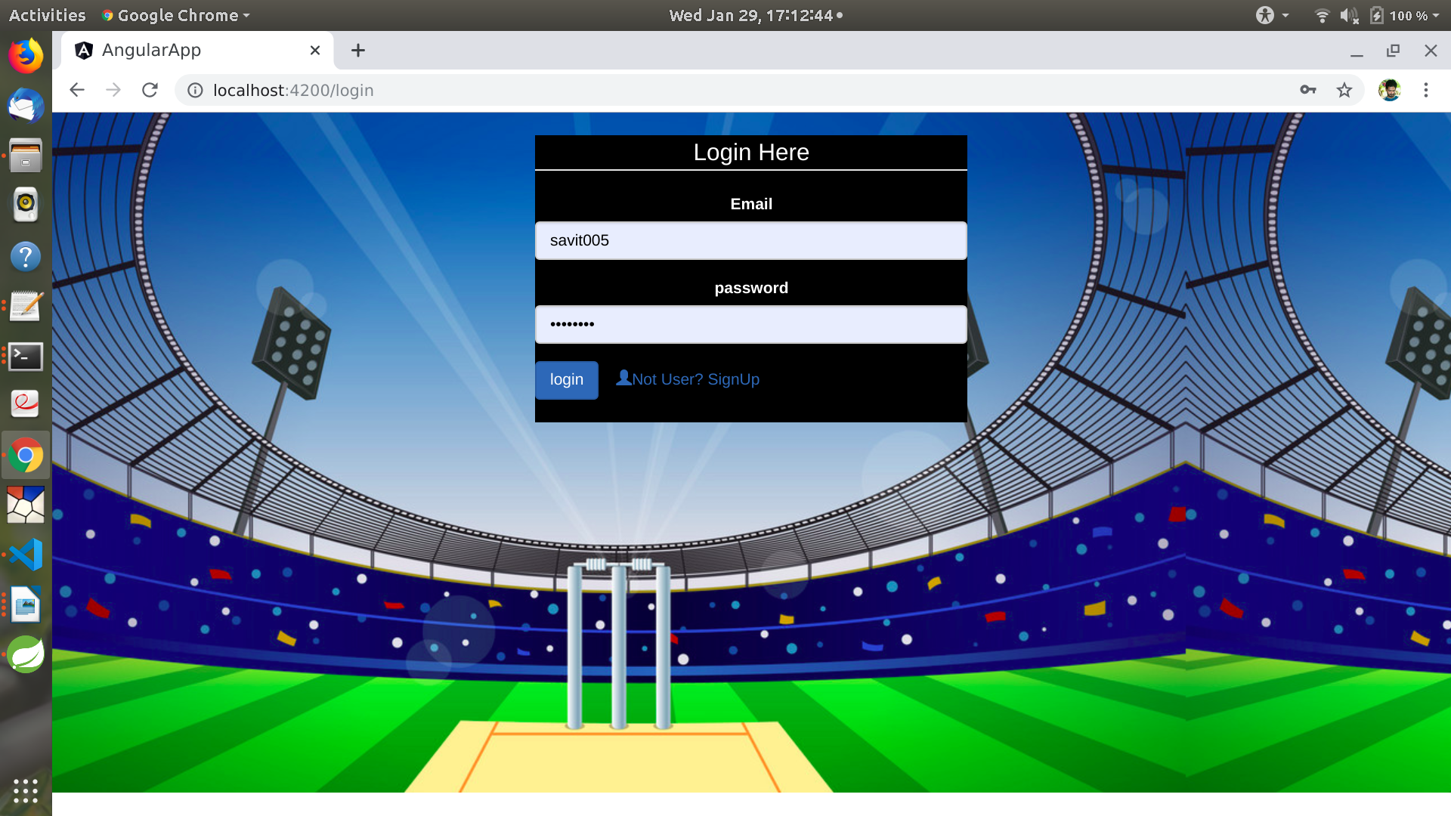

AdminHomePage: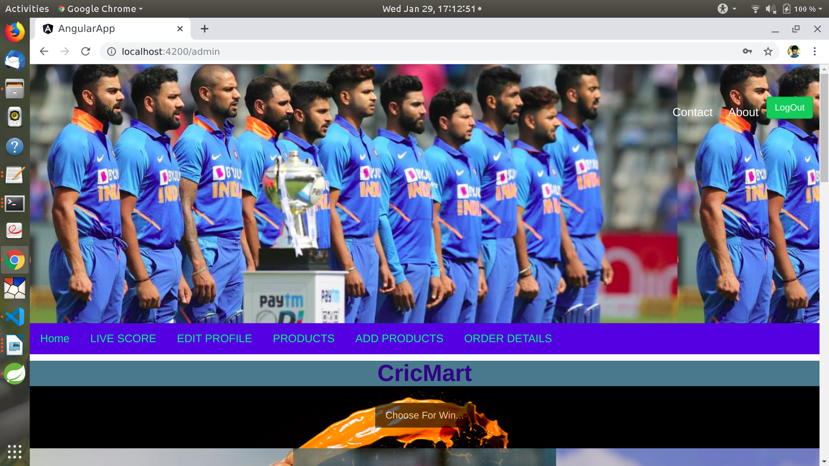

Administrators Login:

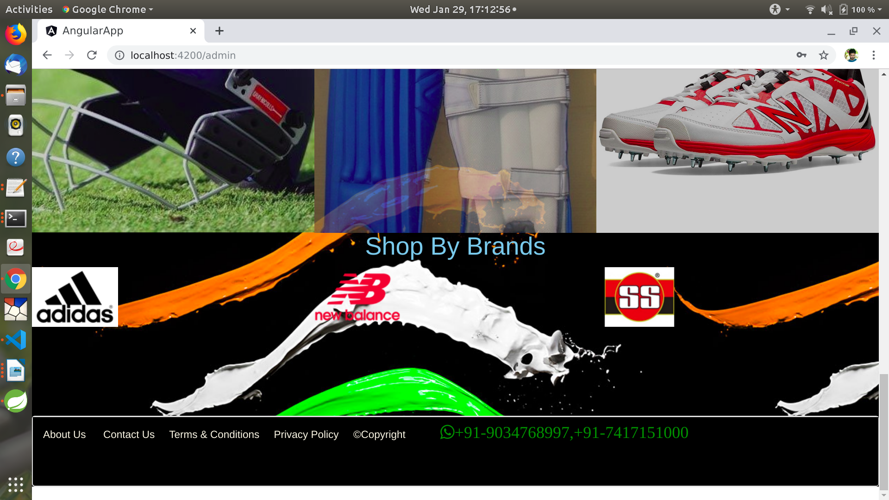

User Registration:

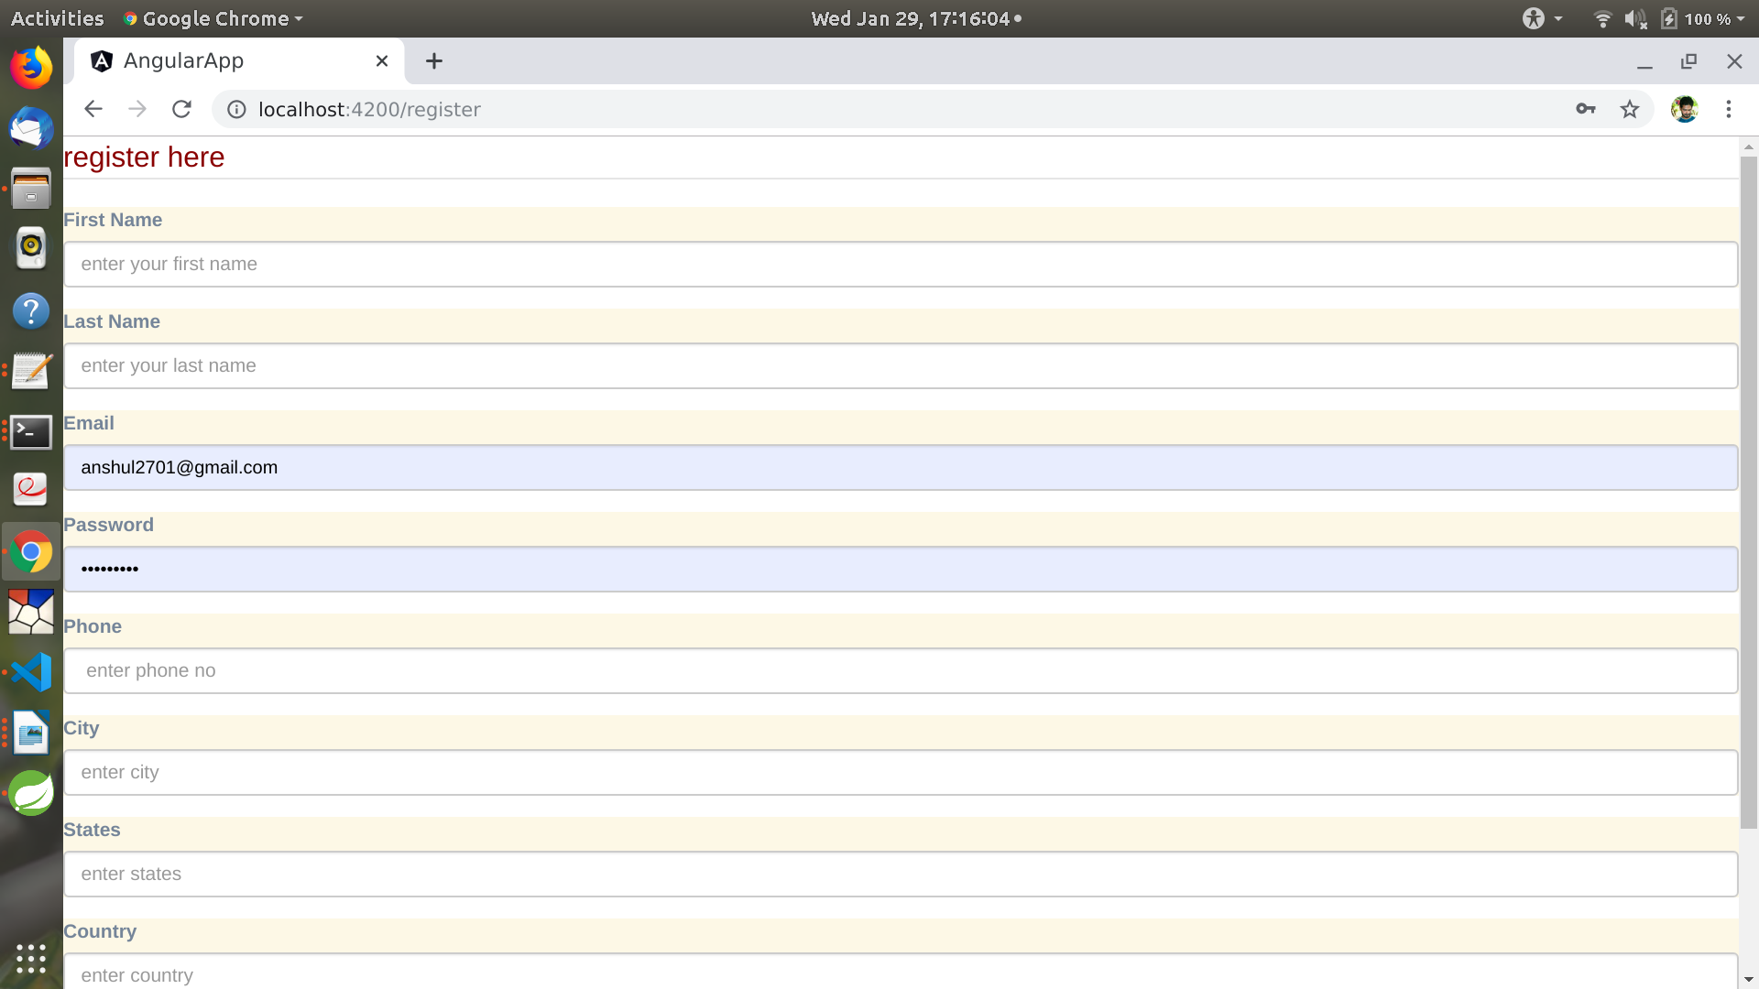

**Add Product**

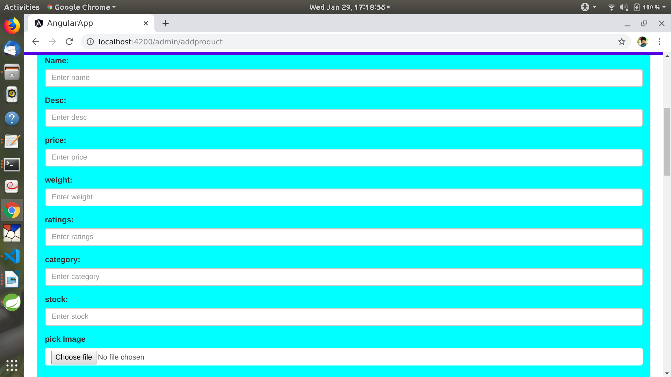

**ShowProducts**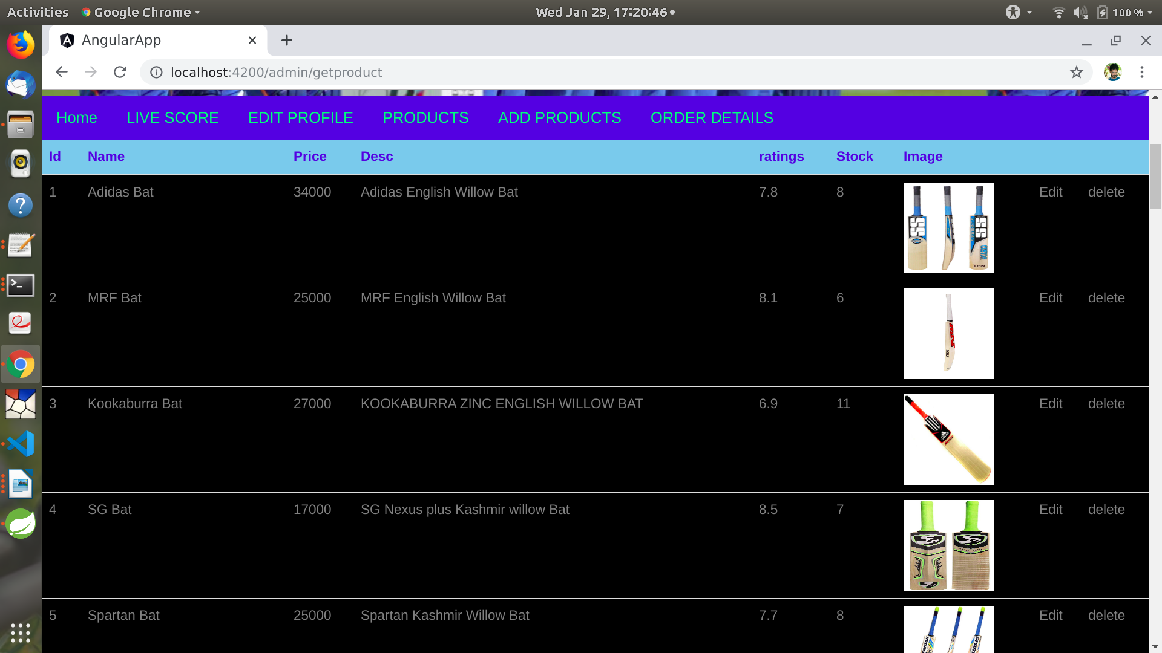

**Edit Product**

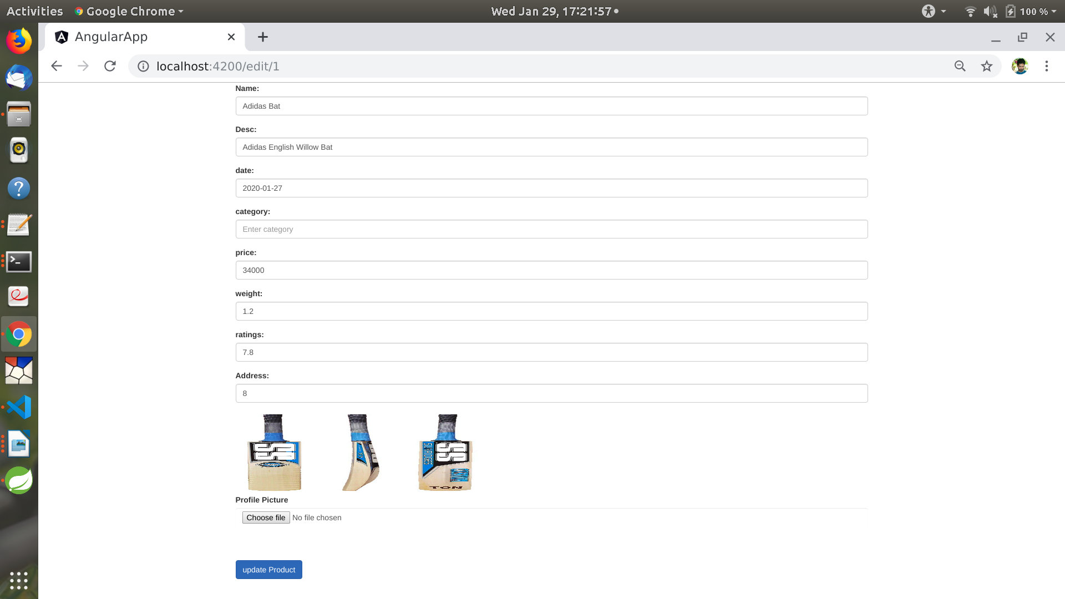

**OrderDetails:**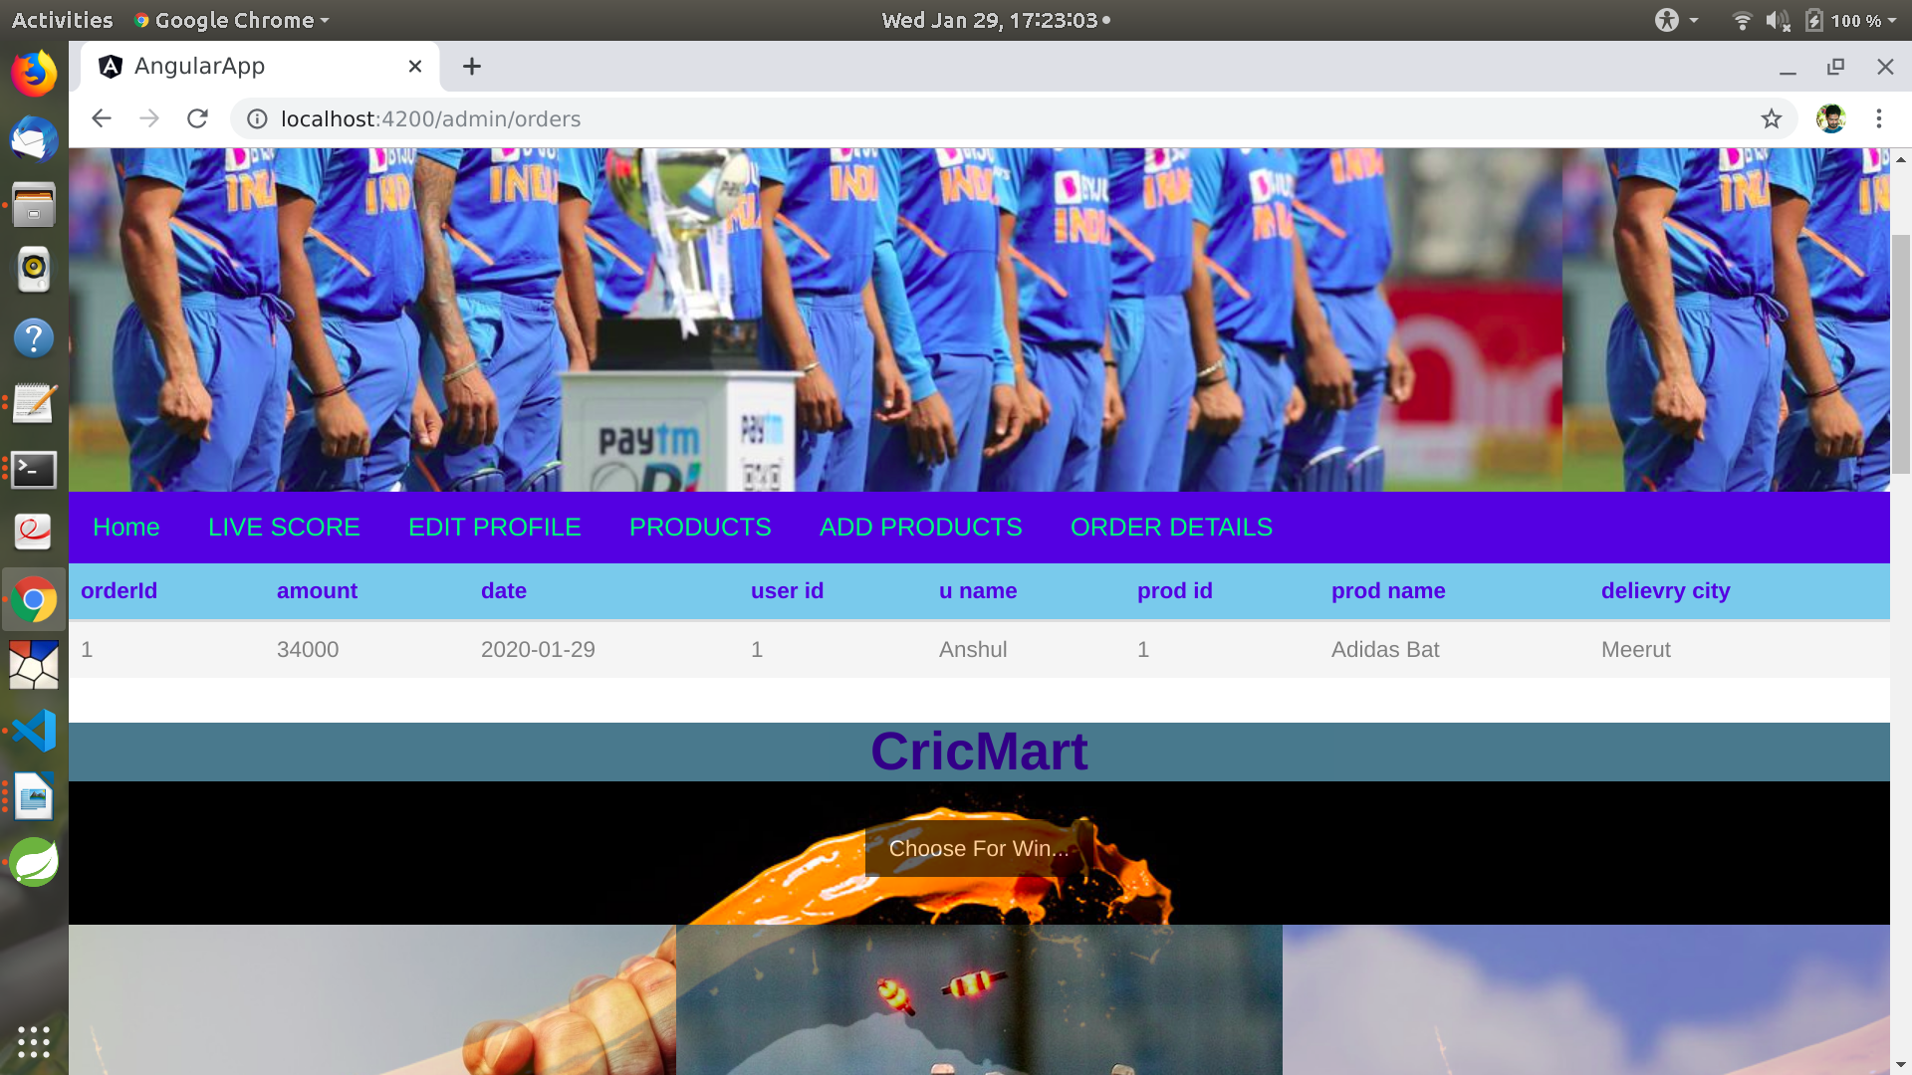

CustomerLoginHomepage: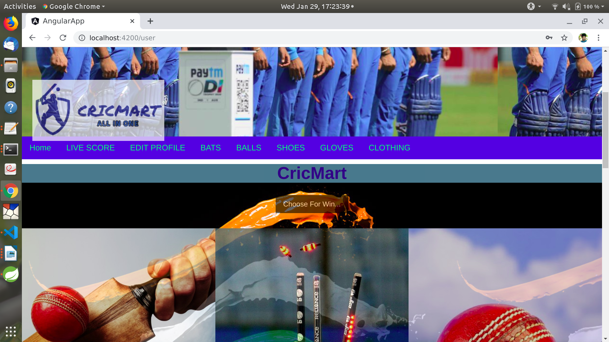

CustomerProductShow: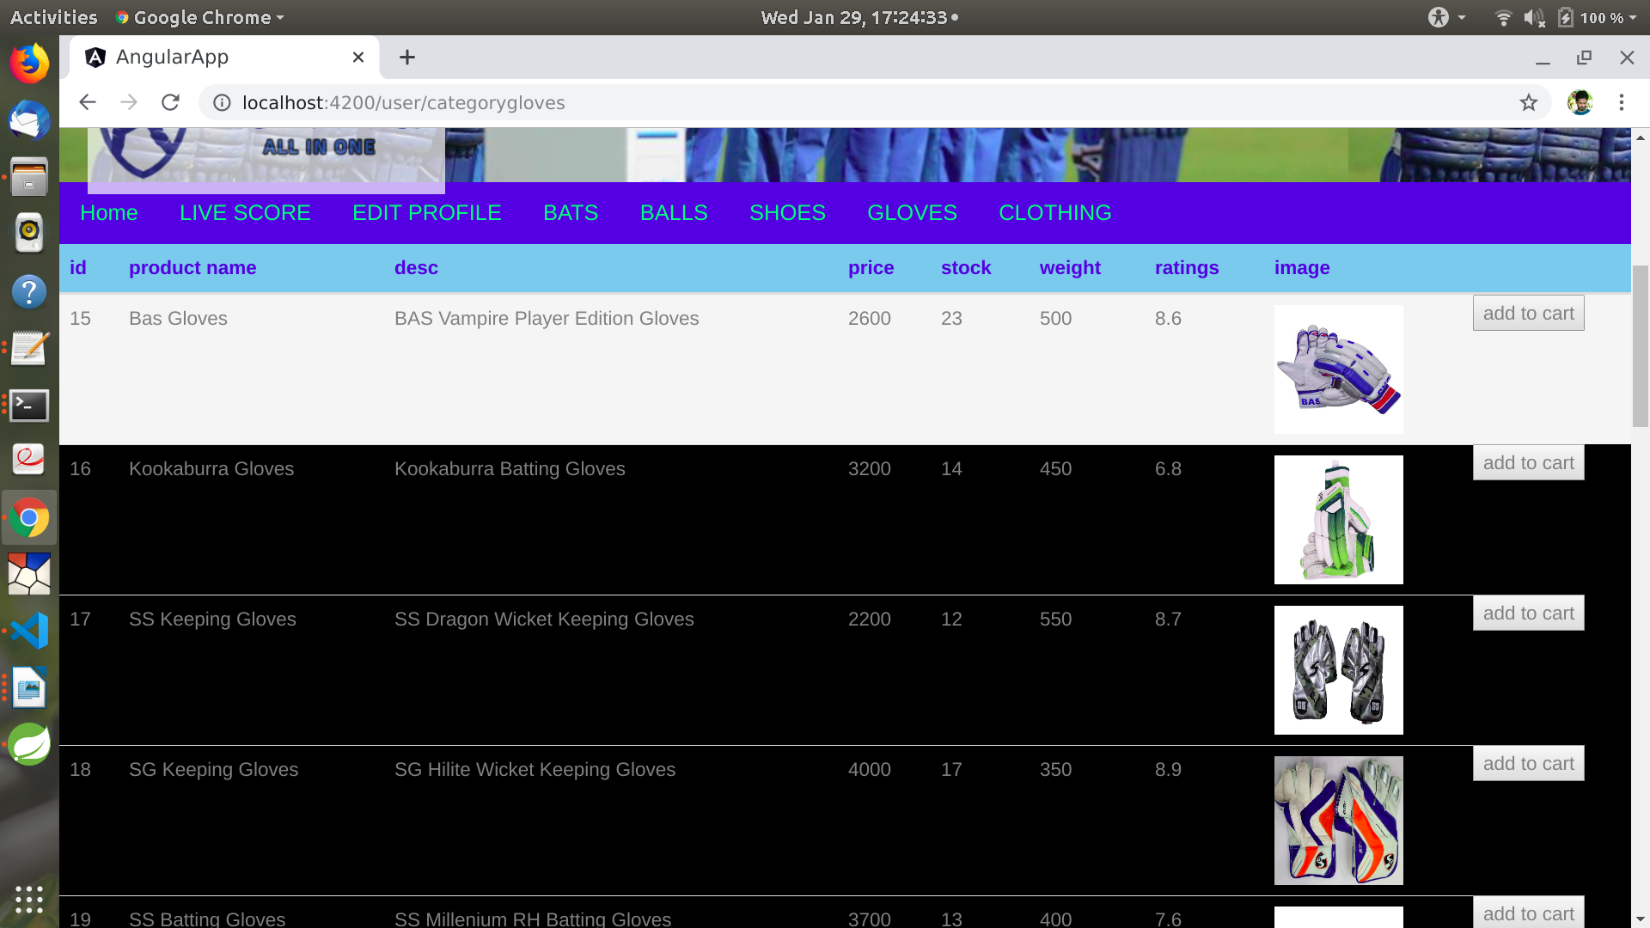

CustomerCart: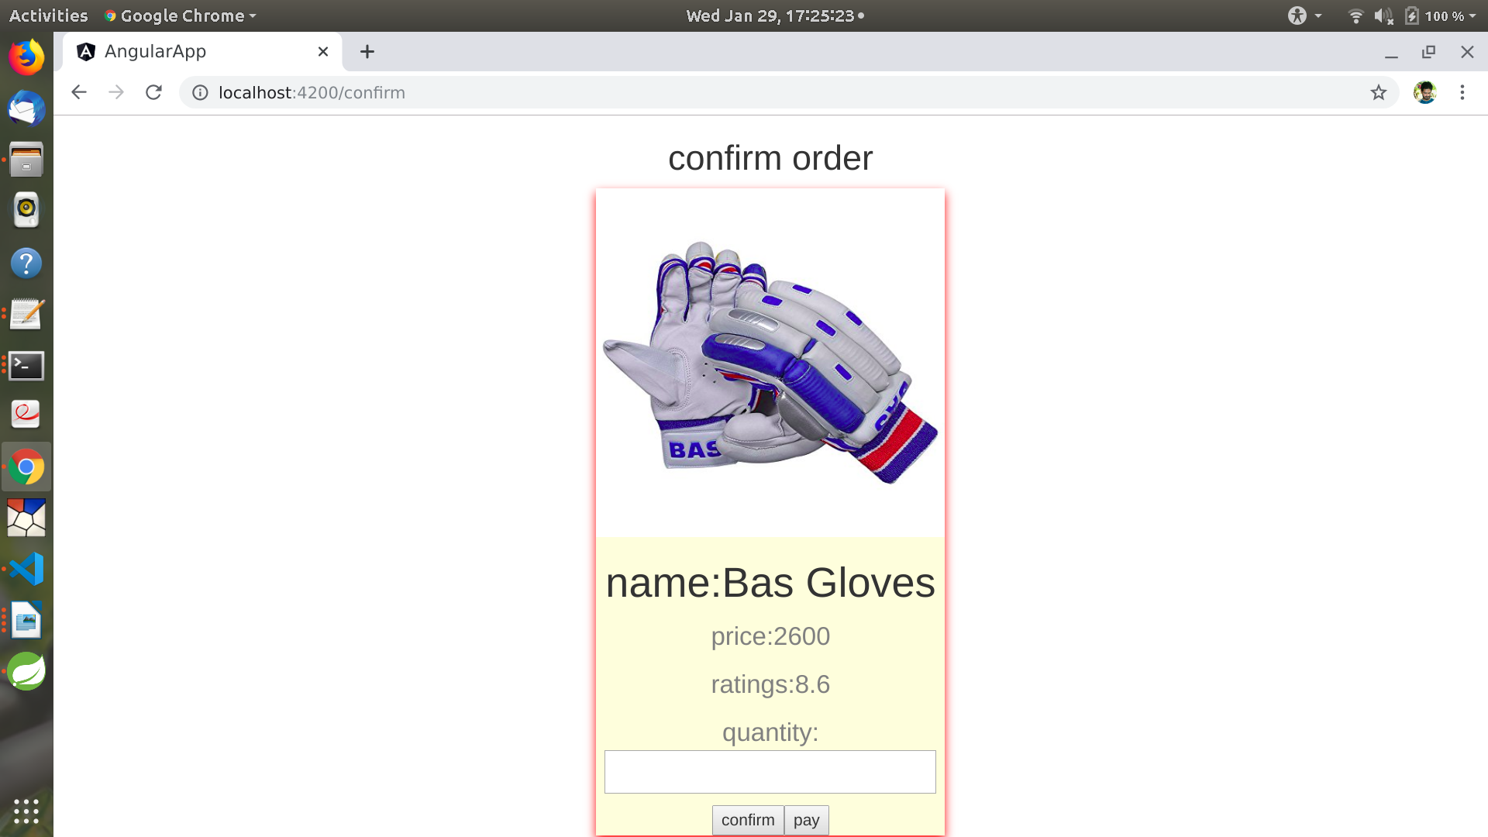

**7.REFERENCES:**

[http://www.google.com](http://www.google.com/)

[http://](http://www.xml101.com:8081/xml/)www.cricbuzz.com

[https://www.onlinecricstore.com](https://www.onlinecricstore.com/)

<https://www.amazon.in/>

http://www.w3.org

http://www.wikipedia.org